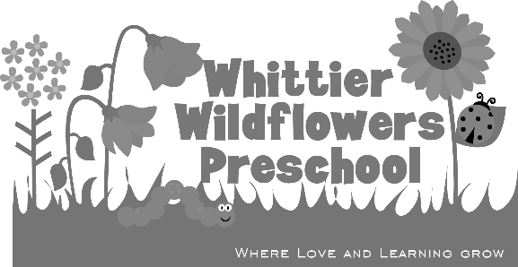
General Permission Form – Toddler

Child’s Name __________________________________________ Date _____/_____/_____

I give permission for Whittier Wildflowers Preschool staff to change my child’s diaper as needed. I give Whittier Wildflowers Preschool staff permission to use diaper cream as requested and provided by me when needed.
___________________________________________
Parent’s Signature

I give permission for Whittier Wildflowers Preschool to use hand sanitizer on my child when it’s not possible to wash at a sink. I understand that the children will be closely supervised while using hand sanitizer.

___________________________________________
Parent’s Signature

