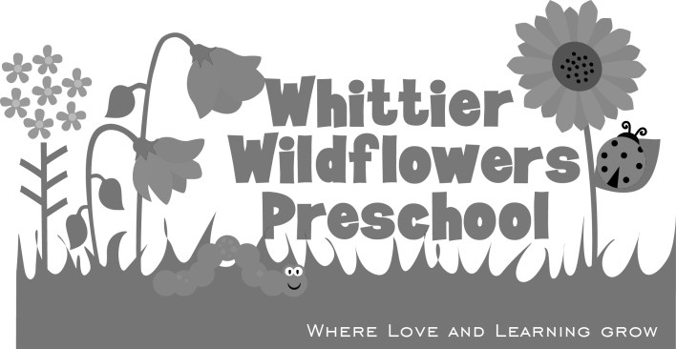

Photo Release

For valuable consideration, I agree that Whittier Wildflowers can use any photographs that it takes of my minor child for any purpose it might reasonably select.
I understand and agree that my minor child may be included with other children in the photographs.

Dated: _______/_________/__________

Minor’s Name: ____________________________________________________

Parent or Guardian: _____________________________________________________

Address: ___________________________________________________________

City: ___________________________________________________________

State/Zip: ___________________________________________________________

Phone: ___________________________________________________________

